臺灣學術倫理教育資源中心操作手冊
必修學生(Mandatory Students English Guide)

製作日期：2016年9月11日

本手冊適用將本課程列為必修、口試或畢業門檻之學校學生。
（若您使用電腦瀏覽，可直接點選下方目錄閱讀）
中文版操作手冊Chinese Guide 1
1.登入網站 1
2.修課與測驗方式 3
3.其他問題 6
4.聯絡資訊 8
英文版操作手冊English Guide 9

【教育部校園學術倫理教育與機制發展計畫辦公室製作】

中文版操作手冊Chinese Guide

1.登入網站
1-1.輸入網址：ethics.nctu.edu.tw ，即可進入「臺灣學術倫理教育資源中心」網站。
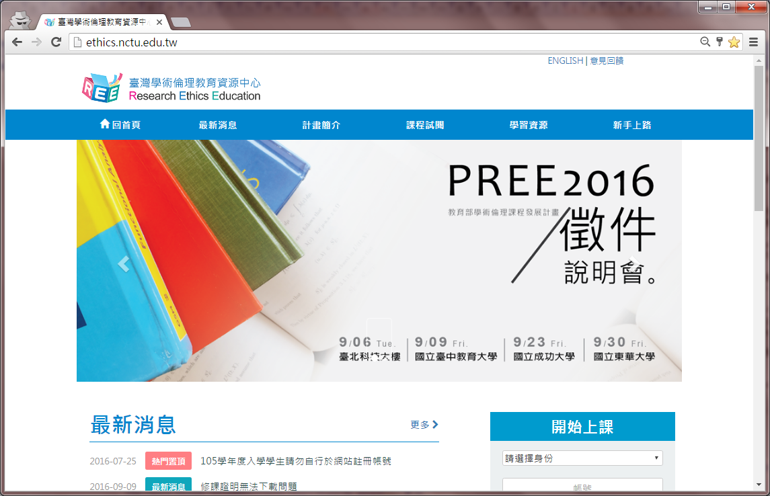
1-2.身份請選「必修學生」，並選您的學校，帳號為學號，密碼預設學號末5碼，輸入驗證碼後登入。
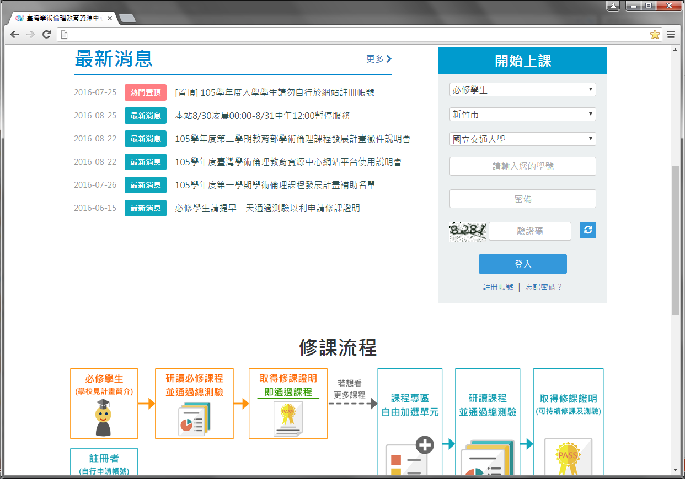
1-3.登入後，顯示個人資訊狀態首頁，呈現各校校園公告、學生修課進度，若需修改密碼或電子信箱，請於網站上方點選［個人資料］方可更改。
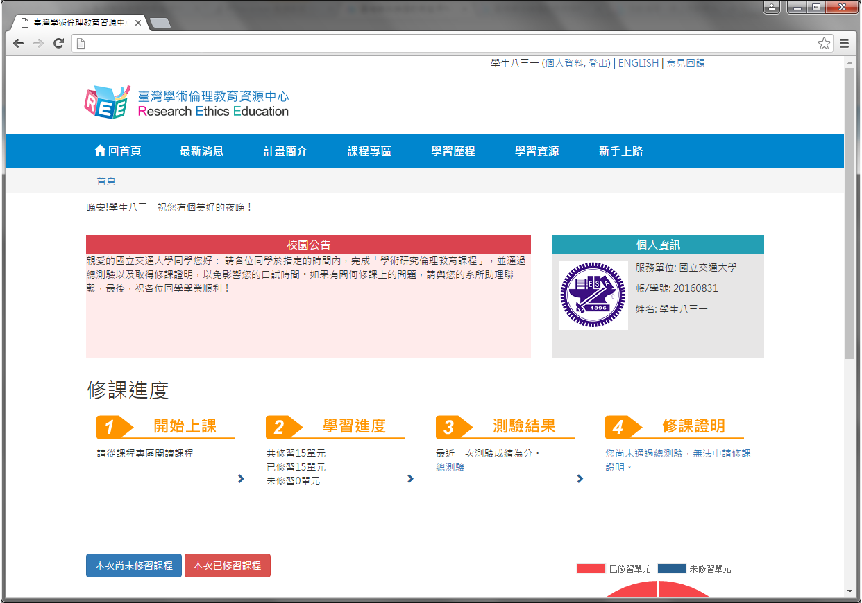

2.修課與測驗方式
2-1.登入後，修課請選擇［課程專區］，［課程總覽］列出所有線上課程。注意：系統已預選15個核心單元（無法退選），您必須至[我的課表]閱讀全部核心單元後才能進行總測驗，通過測驗後，可至［課程總覽］加選其他專業領域單元進行學習。
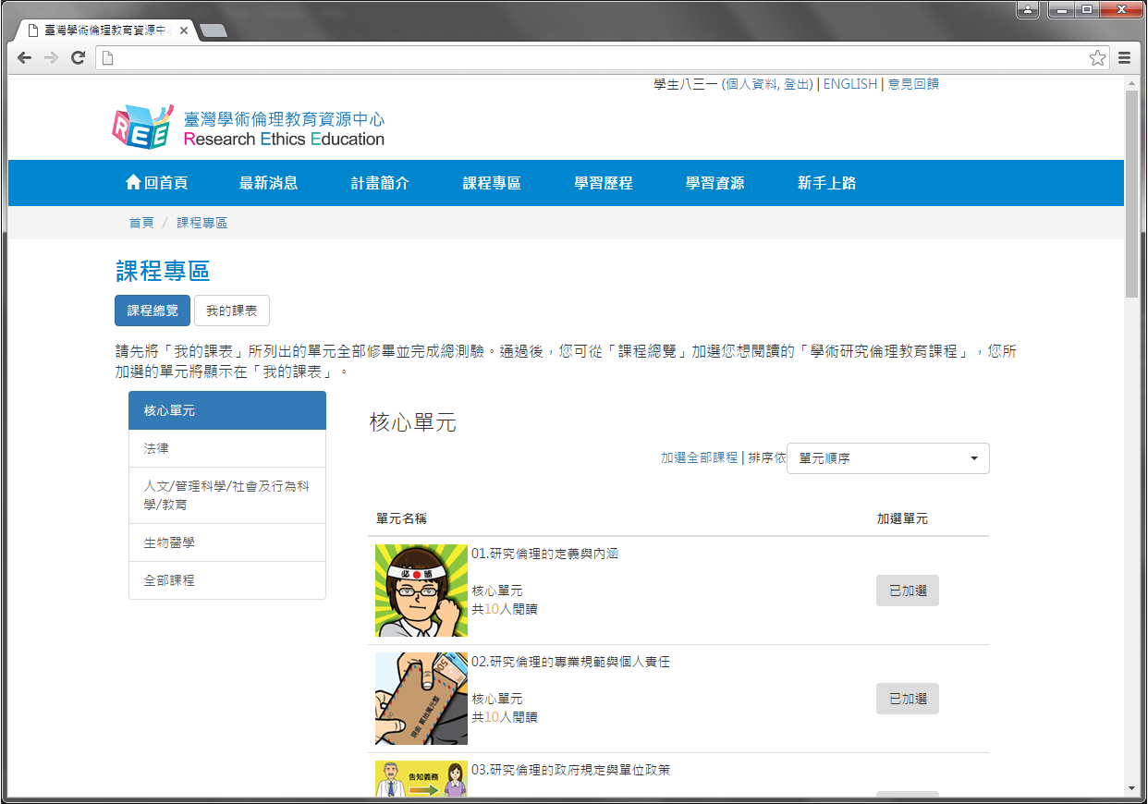
2-2. ［我的課表］顯示已加選單元，點選單元名稱即可進入教材閱讀，已修讀過的單元將顯示修課日期，修讀全部核心單元後，頁面下方「總測驗」按鈕會亮起，點入即可測驗。
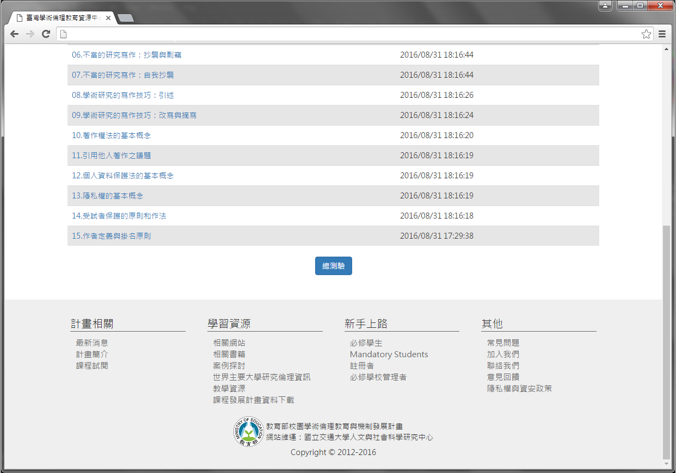
2-3.點下「總測驗」後，將出現說明頁面，請同學務必詳閱規定，若您測驗過程中離開頁面，本次所有填答將不計分，需全部重新作答。為確保您的權益，測驗前請確認使用者名稱為真實姓名，此名稱將印製於修課證明，若需異動，請連絡貴校管理者。
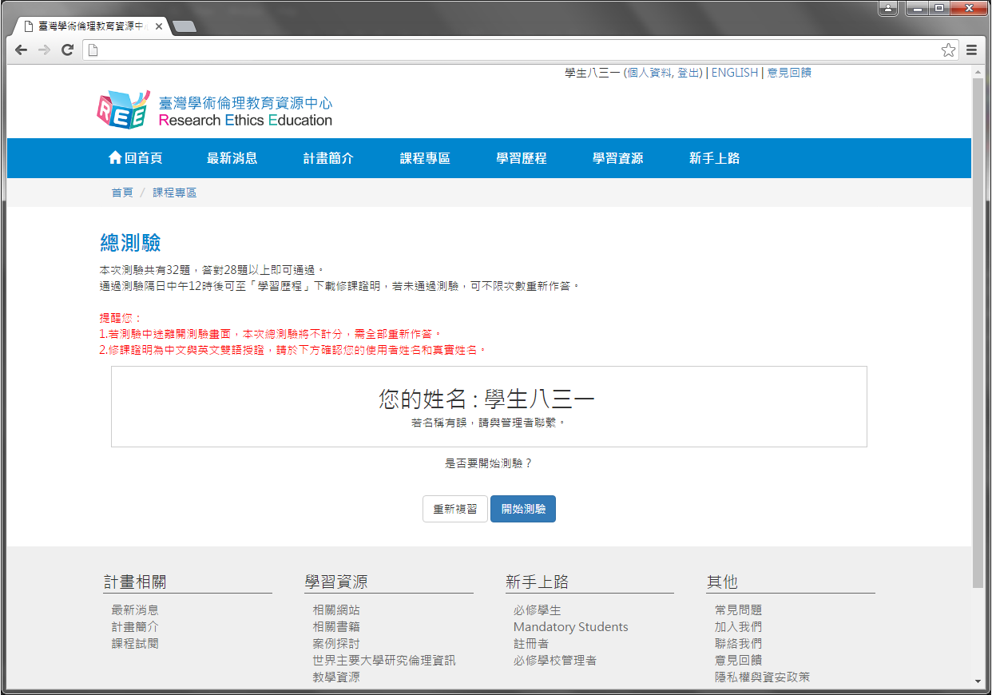
2-4.總測驗皆為4選1單選題，尚未通過測驗前，您可重新測驗直到通過為止（實際完成課程期限由各校規範）。
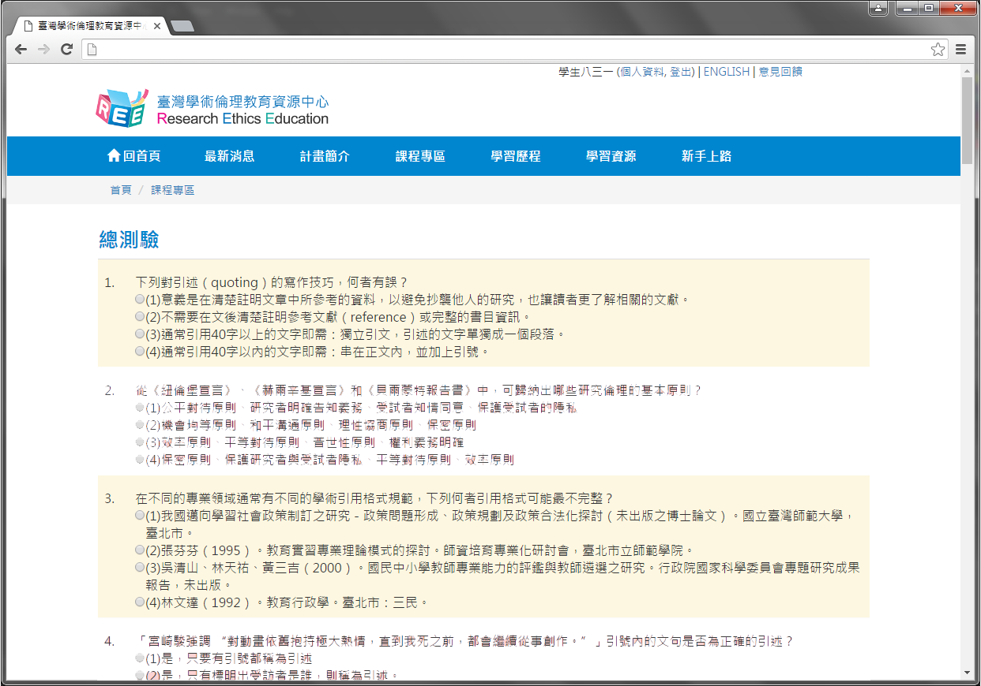
2-5.總測驗結束後，將顯示您本次測驗之答對率、答錯單元統計、答對題數目。
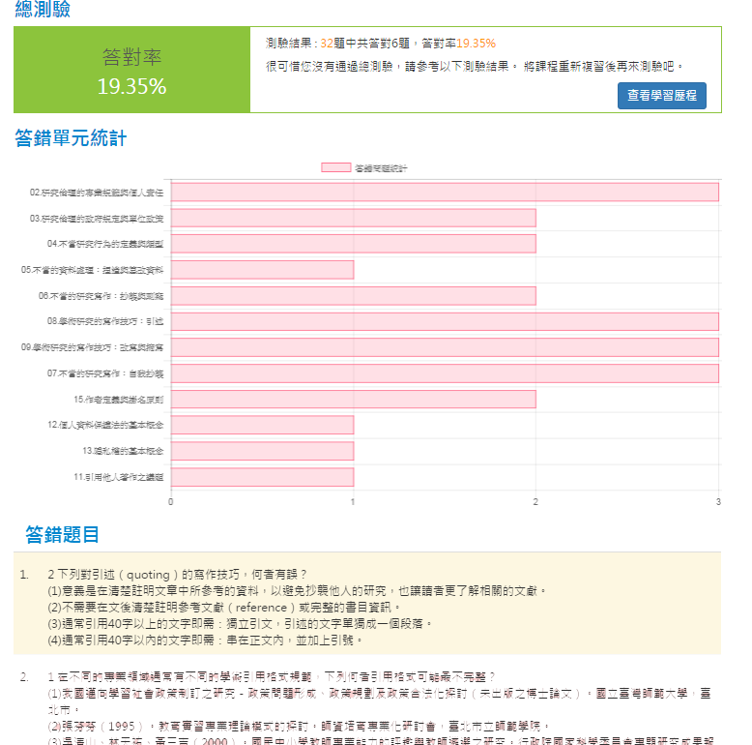
2-6.若您通過總測驗，則於通過測驗後隔日中午12時，至［學習歷程］下載修課證明，您可直接於網站下載PDF檔保存。如需訂正最近一次測驗題目，請點選「前往查看」。
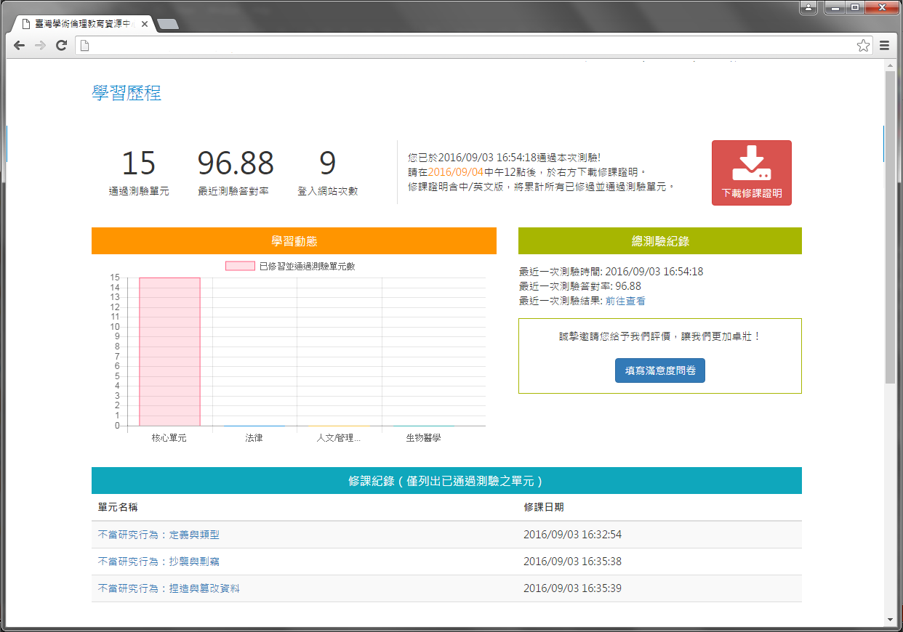

3.其他問題
3-1. 若有操作問題，也可至網站導覽列點選［新手上路］，內有使用步驟說明；或網站下方點選［常見問題］，查看其他問題解答。
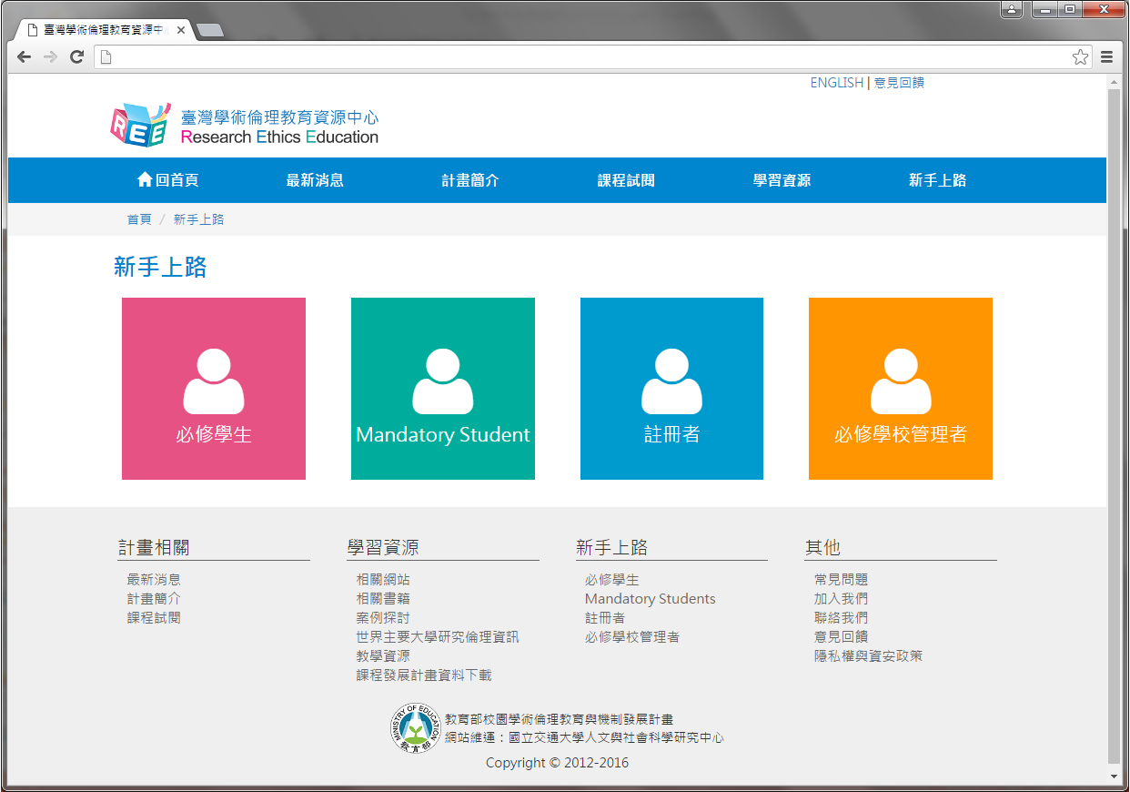

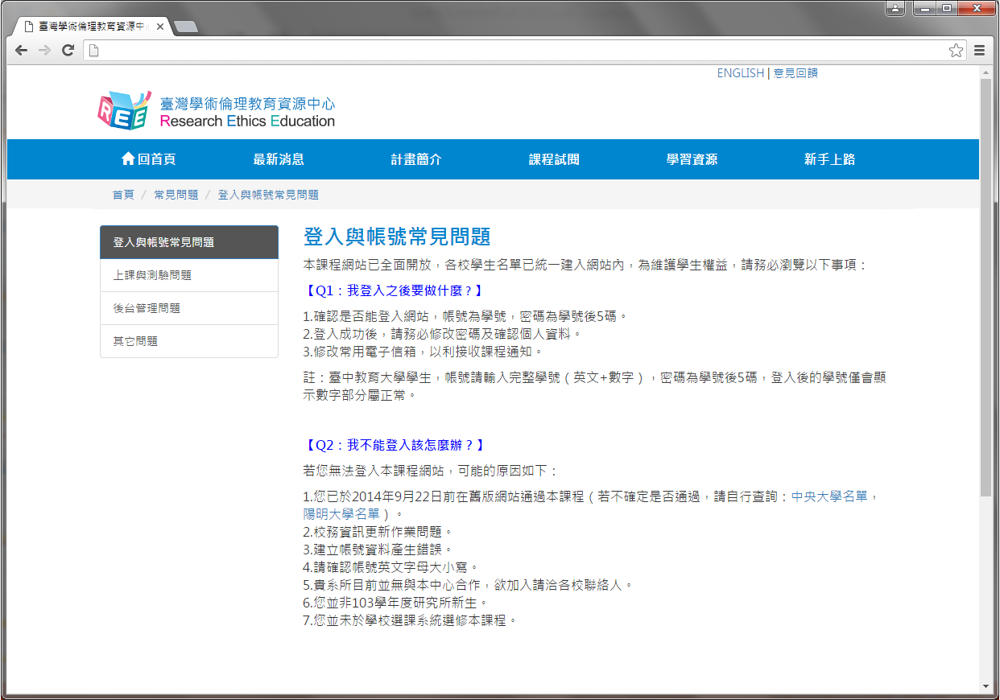
3-2.若網站操作上有任何問題或建議，可至網站上方點選［意見回饋］，填寫問題與建議後，計畫總辦公室將有專人會與您聯繫。
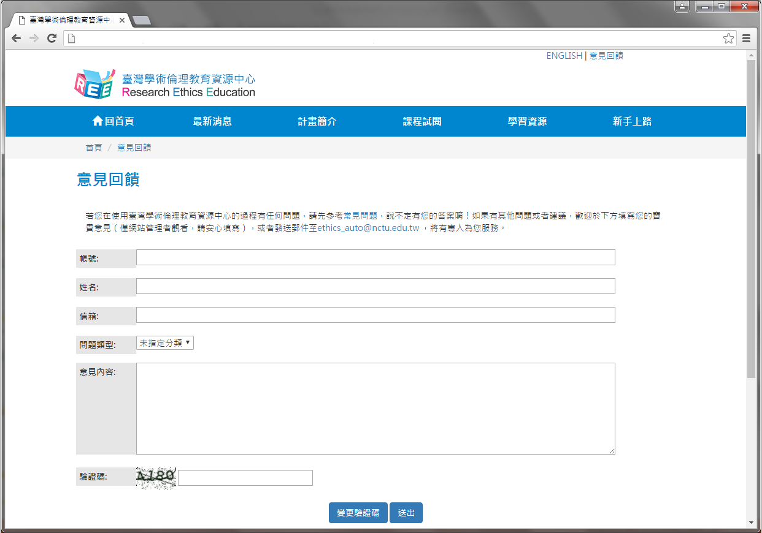

4.聯絡資訊
- 教育部校園學術倫理教育與機制發展計畫總辦公室
- 計畫問題請洽專案經理：高小姐
  - 電話：03-571-2121 #58053
  - 信箱：echolin@mail.nctu.edu.tw
- 網站問題請洽專案助理：姜先生
  - 電話：03-571-2121 #52491
  - 信箱：ctw14161@nctu.edu.tw

英文版操作手冊English Guide
Step 1. Research Ethics Education Center. Website: ethics.nctu.edu.tw
Step 2. After entering the Research Ethics Education Center website, sign in from the right side. Mandatory Students: Please select “必修學生”, your school and enter your student ID as account name. The default password is the last 5 digits of your student ID.
Step 3. After logging in, if you need to change your password or e-mail address, you may do so by selecting “個人資訊” from the top of the page. If you wish to start classes, please select “課程專區”→”我的課表”, and you may browse through the Research Ethics Education Online Program.

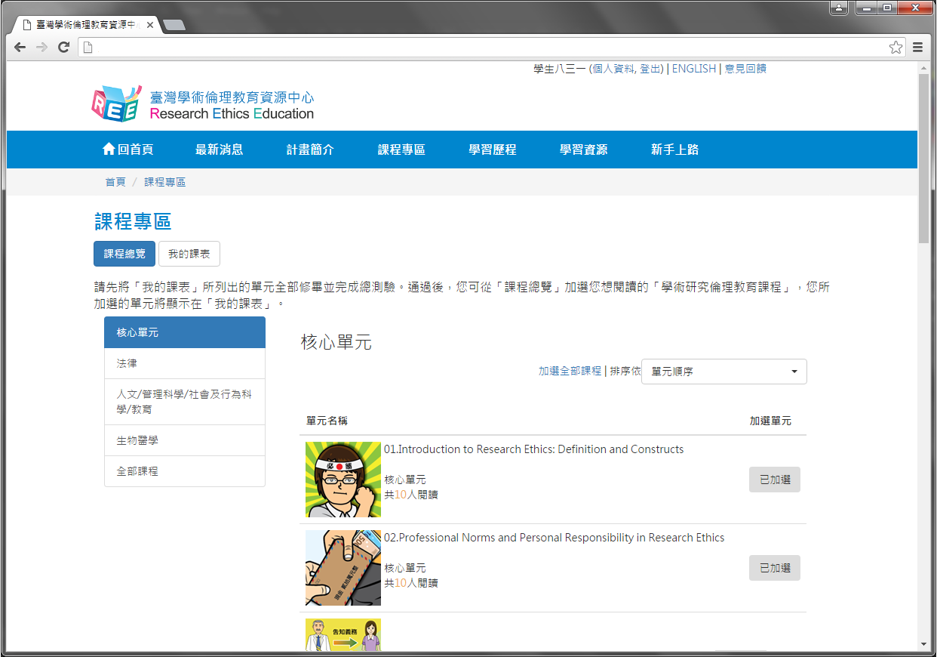

Step 4. After you have completed all core unit(s), you may proceed to the course final exam in “我的課表”. Please select “總測驗” to proceed.
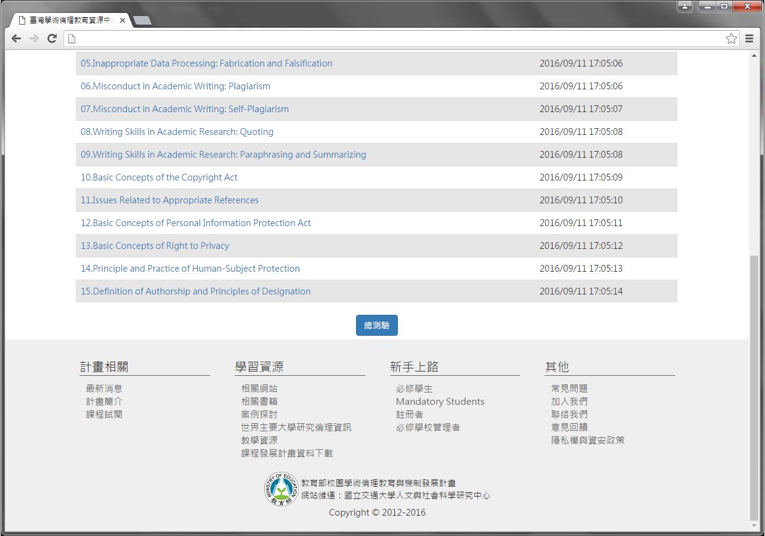
Step 5. Note: Should you leave the page while taking the exam, your answers will not be scored, and you must start over. If you pass the exam, you may apply for the Certificate of Completion. Please verify that your user name is your actual name.
Step 6. Course final exam is consisted of single choice test items with four choices. You have unlimited attempts before passing the exam. Upon completion of the final exam, information such as number of correct answers, percent correct, and etc. will be displayed.
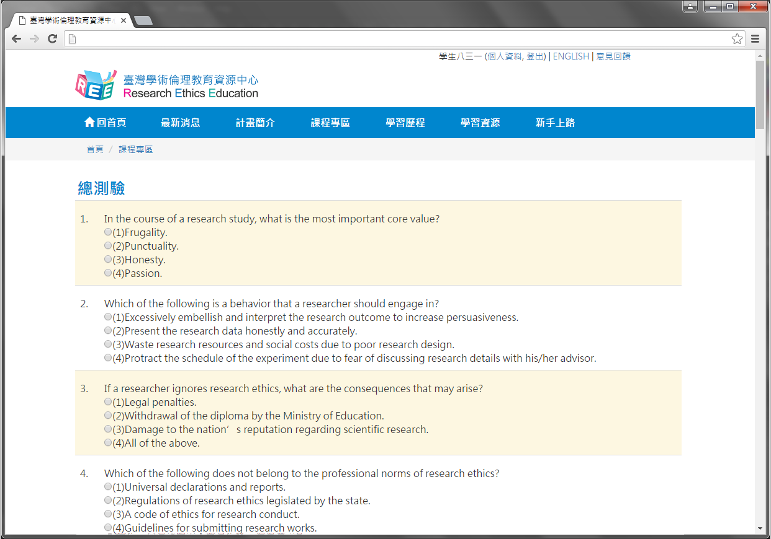
Step 7. If you pass the course final exam, after 12:00 PM, the next day after passing unit(s) exam, “下載修課證明” for Certificate of Completion will appear in “學習歷程”. You may select it and save as a PDF file.

